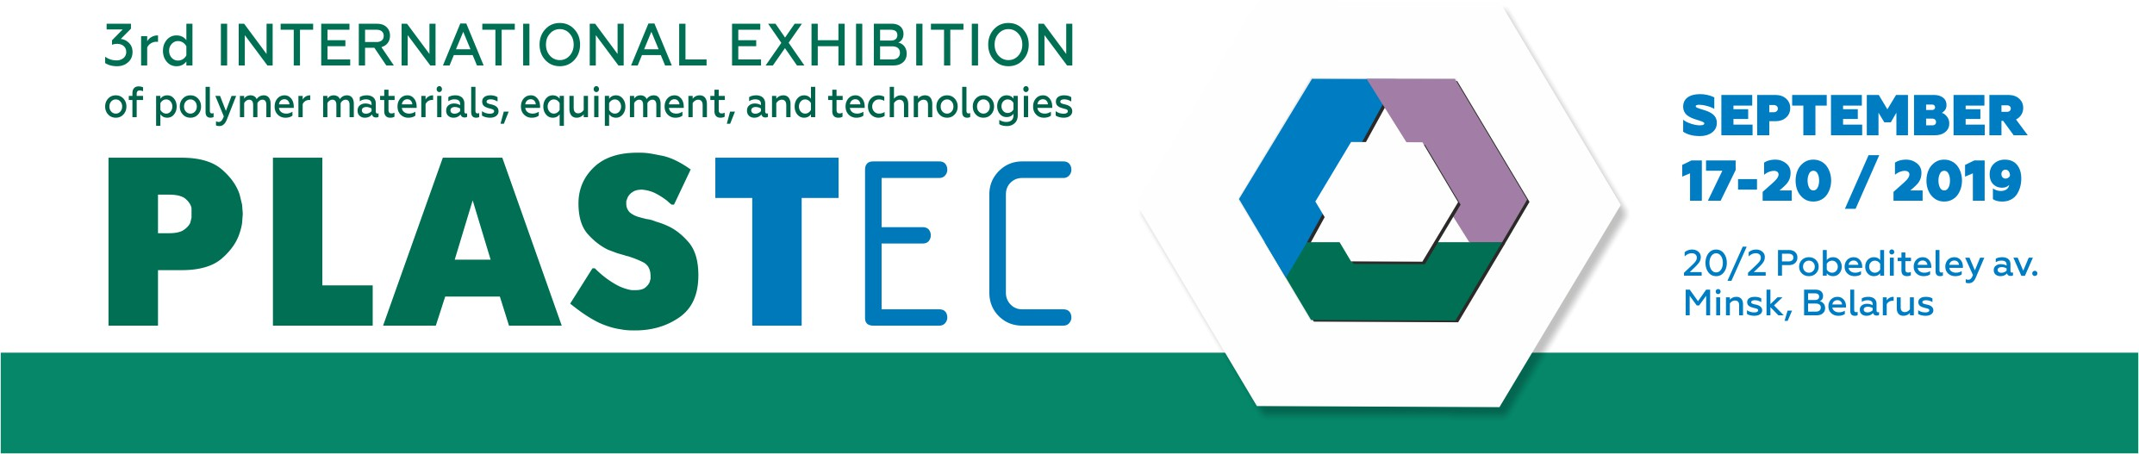
ABOUT EXHIBITION

We invite you to participate in the 3rd international specialized exhibition of polymer materials, equipment, and technologies for plastic products production PLASTEС.
The event is held at the same time and place with the 22nd international exhibition of industrial technologies and innovations TechInnoProm holding under the patronage of the Government of the Republic of Belarus during more than 20 years as well as with the 18th international specialized exhibition CHEMISTRY. OIL & GAS organizing in Minsk since 1994.
Each year the events gather about 300 domestic and foreign Exhibitors and over 5000 Visitors-specialists: heads of companies, engineers, technologists and specialists of industrial enterprises.

PURPOSES OF THE PROJECT:
- To demonstrate the newest technologies of rational and sustainable use of plastic production in the industry.
- To promote modern plastic products used in domestic and industrial sectors.
- To establish and strength business contacts, exchange of experience between industry experts.
- To match producers and consumers together.
- To create a comfort and image space for international and domestic Exhibitors for their best communications with consumers.
- To arrange the attendance at exhibition of target visitors from industrial enterprises, consumer organizations, trade companies, private business, and government institutions.
- To demonstrate a wide range of products and services, areas of appliance and use of polymers.
- To get acquaint with modern high-tech equipment, software, and a wide range of related services.
- To provide with topical information on the current state and prospects of development of the polymer industry; on trends, new technologies, equipment, goods and services in the field of polymer manufacturing.
- To exchange the knowledge and experience, to create partnership, professional and personal growth of experts.

TIME AND VENUE:
September 17 – 20, 2019 / Minsk, Belarus,
20/2 Pobediteley av., Roofed Soccer Arena

VISITORS OF PLASTEC 2018:
- Decision makers – business owners, heads of companies, CEOs – 27,3%
- Top managers, heads of departments, divisions, and groups, project managers – 36,2%
- Specialists aimed to purchase products / services according to results of exhibition – engineers, technicians; representatives of planning organizations, industrial enterprises, Committee for science and technologies; final consumers, producers, buyers and suppliers of goods and services, representatives of small and medium sized businesses, industrial designers, consultants – 32,4%
- Individual entrepreneurs – 2,5%
- Private persons – 1,6%

BUSINESS PROGRAM
Seminars, conferences, presentations, and masterclasses.

MARKET OF PLASTICS AND POLYMERS
The market of plastics and polymers is permanently growing and dynamically developing in the Republic of Belarus. In spite of critical situations in the world economy, their consumption is increasing actually. Plastics and polymers are the most important structural materials of modern technics and machines; they replace traditional materials (metal, wood, textile, glass, paper, etc.) in the industrial production.
EXHIBITION SECTORS
1. Machines, equipment, and technologies for production and processing of polymers
1.1. Machines and equipment (main and peripheral) for preprocessing.
1.2. Machines and equipment (main and peripheral) for recycling and processing of plastics.
1.3. Machines and equipment for finishing processing, sets and devices for the outer surface finishing, coating, labeling, and printing.
1.4. Equipment for plastic welding, cutting tools, high-precision sets.
1.5. Accessories (forms, stamps, etc.).
1.6. Means of integrated automation, peripheral devices, Control and measuring equipment.
1.7. Environmentally friendly technologies and production lines.
1.8. Means of production infrastructure: ovens, chillers, robotics, etc.

2. Raw and auxiliary materials
2.1. Thermoplastics, elastomers, durable plastics, foams, composites.
2.2. Fiberglass and metal-polymers.
2.3. Caoutchouc and rubber.
2.4. Bioplastics and ecoplastics.
2.5. Half-finished products: synthetic fibers and sutures, filaments, profiles, sections, leafs, tubes.
2.6. Coatings.
2.7. Ingredients: polymer resins, additives, fillers, color pigments, concentrates, chemicals, adhesives, other raw auxiliary products.
2.8. Reinforced materials and fibers.
2.9. Materials, consumables.

3. Plastic and rubber products, finished goods
3.1. Products obtained by blow molding.
3.2. Products obtained by extrusion.
3.3. Reinforced plastics.
3.4. Products obtained by cast molding and calendering.
3.5. Laminated parts.
3.6. Products obtained by machining.
3.7. Products obtained by compression molding.
3.8. Products obtained by rotary molding.
3.9. Products obtained by foaming.
3.10. Products obtained by die casting and founding.
3.11. Products obtained by vacuum forming, thermoforming.
3.12. Products obtained by vibroforming.
3.13. Products obtained by welding.

4. Services for the industry of polymers and rubber
4.1. Consulting.
4.2. Software, IT maintenance, monitoring.
4.3. Modeling and design of finished goods.
4.4. Research, development and innovation projects.
4.5. Specialized unions and associations.
4.6. Trainings, developmental education.
4.7. Leasing, trade.
4.8. Equipment and technology for the collection and recycling of plastic waste.
4.9. Packaging, marking, logistics, and warehouse equipment.
4.10. Industrial safety and labor protection.

5. Additive technologies, 3D scanners and 3D printers, materials for 3D printing
6. Polymer packaging and adhesive films
7. Specialized editions, portals, media

COST OF PARTICIPATION
for the entire period of the exhibition, excluding VAT, VAT=20%:

Registration Fee – 190 EUR
Equipped exhibition area (booth) – 87 EUR / 1 sq.m.
Unequipped exhibition area – 60 EUR / 1 sq.m.
Open exhibition area outside pavilion – 20 EUR / 1 sq.m

ORGANIZER ADDRESS
EXPOFORUM Exhibition Company
91 Pritytskogo str., office 432
220140 Minsk, Belarus
www.expoforum.by

CONTACTS
Nicolaévich Alexander – Head of the project
+375 17 314 34 38, e-mail: global@expoforum.by

